**Assignment 2 Final Report**

**Research Question**

What are the connections between Victoria's environmental greening and the life quality of the resident?

**Introduction**

Enhancing live quality is what people always aspire to, where many factors have impacts on. Environmental Greening is one of the new factors that needs to be looked into, as this may construct livability, health and sustainability in Victoria’s community.  Formidable greening allows the city to feed itself with sustainable reliance on the surrounding natural environment, and it also purifies the surrounding air. Greening creates a natural environment in suburbs, creating not only shadows for people, but also homes and shelters for animals and insects, making the suburb environmentally friendly. This could affect an individual's physical and psychological health, which will be explored in this report.

The research on which this report is based had as its key aim to investigate the relationship between environmental greening and Victorian resident’s livability, in which livability in this report is chosen to be suicide rates and cancer cases in each area.

It is anticipated that this study will provide further evidence that vegetation coverage in each area will influence Victorian residents’ livability in different ways. Datasets used in this research are Population estimates by age and sex (SA2, 2019), Melbourne Metropolitan Region Urban Vegetation Cover (2018) Tree Coverage Loss and Suicide and Self-harm Monitoring from Australian Bureau of Statistics, Victoria State Government and Global Forest Watch. Other research reports will also be drawn to support findings in this report.

**Analysis Techniques and Investigation Methodologies**

**•Data Collection and Cleaning**

For data of suicide rate vs. vegetation coverage, data of vegetation coverage is manually collected into excel, since the data source is a PDF and not many data are available. Two datasets are linked through suburbs, compared and analysed. Suicide rates are read from local file using dataframe with S11 spreadsheet, select Victoria’s data, and rename column name. Use dataframe to open vegetation coverage excel, compare the suburb name in a for loop, if suburb name match, then create a new dataframe with both vegetation coverage and suicide rata. Use polyfit to obtain the relation between suicide rate and vegetation coverage and draw a trend with the equation, also a scatter plot.

All of the data collected are already cleaned and fit, but some are not appropriate for analysis then manually transfer is required.

**•Visualisation Methods**

A scatter plot is chosen as it can provide a clear view of the distribution of the data points, and is able to show the relationship between suicide rate and vegetation coverage through a trend.

To analyse the relationship between cancer cases and the loss of tree coverage, both are collected into excel format due to the data information being displayed in PDF format, which is not able to be read from a local file by using dataframe. Through the comparison of annual cancer cases and vegetation coverage, the graph demonstrates the connection between the cancer cases and vegetation coverage; therefore, we choose to use the scatter plot and apply a trend line to show the result.

For the data that was collected, we created a series with value and index. While in dataframe, create a subset of dataset for cancer cases and tree coverage loss area annually, once we sorted the data in two groups, then scatter plot them with python code or excel.

**Results**

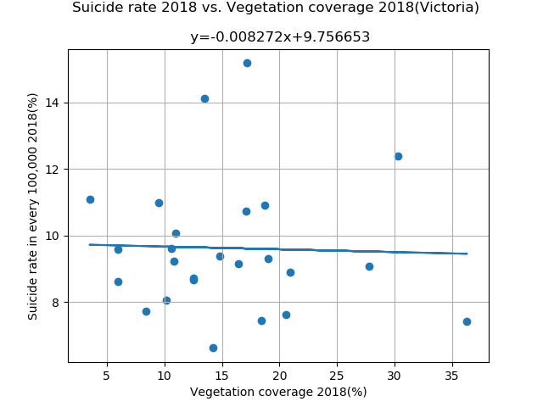

From the graph above, it can be seen that when the tree coverage percentage increases, the suicide rate in every 100,000(%) decreases. A negatively weak correlated relationship can be observed, while also containing some outliers. It can be observed there are few points where the suicide rate is considered high compared to the others when the tree coverage is around 10 to 20 percent.

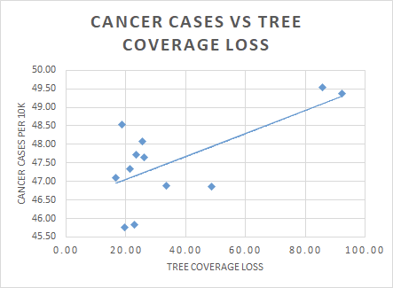

The graph above displays the relationship between cancer cases and the loss of tree coverage. It can be observed that it is a positive correlation which means that when the tree coverage loss increases the cancer cases per 10k also increases. A cluster can also be seen on the graph when the tree coverage loss is about 20.

**Discussion**

*Suicide/vegetation coverage:*

Based on the graph, a negative correlation is observed between suicide rates and vegetation coverage, where the larger the proportion of vegetation coverage, the relative suicide rates decrease. This phenomenon matches Hall & Dickson’s finding (2011), where living in naturalized settings makes people feel more energized, consequently having a positive effect on an individual's overall mental health in that area.

Another finding of Hall & Knuth (2019) discovers that increased access to green spaces reduces psychological distress, depression, anxiety, and mood disorders, which is the main factors that could cause suicide. A positive mental health will result in the reduction of mental stress, which will then decrease suicide rate in an area, improving resident’s livability. The relationship between vegetation coverage and suicide rates aligns with Hal & Knuth’s finding, which further supports the findings based on the dataset.

The few outliers observed from the graph, which is an indication that suicide rate is also affected by other factors that are not evaluated in this research.

Based on the result and other two researches, greening in suburbs positively affects individual’s psychological health, reducing stress and improve moods, which further reduces suicide rate in an area as people are psychological healthier and happier.

However, some limitations occurred during the data analysis. Suicide rate are obtained as 2014-2018’s average, and 2018’s suicide rate along is only provided in PHN (6 data), which will result in inaccuracy of the relationship. Only around ⅓ of the suicide rates are useful in this analysis, where the rest are not able to be used due to the lack of data of vegetation coverage in suburbs.

*Cancer cases/tree coverage loss:*

The trend line obtained from the image reflects the increasing relationship between the reduced area of tree coverage and cancer cases. With the decrease of tree coverage every year, the number of cancer cases in Victoria is gradually increasing every year. The dataset that collected reveals that, from 2001 to 2020, Victoria lost 1.57Mha of tree cover, equivalent to a 25% decrease in tree cover since 2000, and 554Mt of carbon dioxide emissions. Furthermore, the increase rate of cancer cases in Victoria from 2001 to 2015 has grown from 457.6 cases per 100k persons into 468.8 cases per 100k persons. Based on these two datasets, the trend line established the result, which is lower vegetation coverage often accompanied by higher cancer cases in residential areas.

However, with datasets collection, there are some limitations that are inevitable, for example, during the assembly range in 2001 to 2015, the trend line banished the outliers during 2007 to 2010, which leads to higher cancer incidence during those 4 years. Exclusive data affecting the result of the trend line may not be persuasive or accurate.

As the loss of tree coverage increases, the chances of getting engagement with nature decreases. Studies have been done and it is widely known that spending time in green can reduce and relieve stress, lower blood pressures and offer many other health benefits. This can be further supported with the research by Lachowycz and Jones(2013), in which they proposed that engagement with nature is one of the major pathways to better health. Kuo (2015) also suggested plants have some antimicrobial organic compounds which will boost immune system functioning.

Associations between engagement with forests and beneficial immune responses, for example expression of anti-cancer proteins, have been demonstrated (Li et al. [2008](https://link.springer.com/chapter/10.1007/978-3-319-56091-5_11#CR70)). This proposed that one’s physical health, especially the chance of getting cancer could be improved by just having engagement with greenery.

The relationships of vegetation coverage between suicide and cancer rate obtained from the results are still, considered to be valuable as it indicates that both relationships are related with the life quality. It will create awareness in the influence of vegetation on suicide and cancer rate, which may be used by Victorian government to target Victorian residents to be concerned on both issues. Thus, reduces the suicide incidents suburbs and increase the conciousness of urban greening and cancer rate.

**Conclusion**

Influence of environmental greening on Victorian resident’s livability is complex, with many factors that affect the improvement of an individual's psychological and physical health.

The aim of this report is achieved, as the data analysis provides evidence of the relationship between environmental greening and livability. Based on the analysis, environmental greening enhances individual’s psychological health as well as physical health, improving Victorian residents’ livability.

Although the report is only based on two aspects, the trend is observed when there is more vegetation cover, the health condition of the residents are better in both physical and psychological health. However, current findings in the research can only be taken as reference, as more accurate data is needed to validate the findings. This research needs to be improved by finding more data from different relevant aspects to make sure that the analysis made is better supported. Besides that, the analysis could be enhanced if there is more relevant and complete data as it would be helpful for deeper analysis and drawing a conclusion. Further research needs to be done to support the finding in this research that environmental greening improves individual’s psychological and physical health, enhancing Victorian resident’s livability.

**References:**

Australia Institute of Health and Welfare, Suicide and Self-harm Monitoring National Mortality Database—Suicide (ICD-10 X60–X84, Y87.0), Aihw.gov.au. Retrieved 10 May 2021, from

https://www.aihw.gov.au/getmedia/aca3fd17-a3dc-4ec8-b6d8-be8e62a46b12/aihw-suicide-and-self-harm-monitoring-nmd-suicide-icd-10-x60-x84-y87-0.xlsx.aspx. Published 2021

Global Forest Watch. (2021). Retrieved 20 May 2021, from https://www.globalforestwatch.org/dashboards/country/AUS/10

Hall, C., & Dickson, M. (2011). *Economic, Environmental, and Health/Well-Being Benefits Associated with Green Industry Products and Services: A Review*. Journal of Environmental Horticulture. Retrieved 20 May 2021, from <https://meridian.allenpress.com/jeh/article/29/2/96/80332/Economic-Environmental-and-Health-Well-Being>.

Hall, C., & Knuth, M. (2019). *An Update of the Literature Supporting the Well-Being Benefits of Plants: A Review of the Emotional and Mental Health Benefits of Plants*. Journal of Environmental Horticulture. Retrieved 20 May 2021, from <https://meridian.allenpress.com/jeh/article/37/1/30/430948/An-Update-of-the-Literature-Supporting-the-Well>.

Hurley, J., Saunders, A., Amati, M., Boruff, B., Both, A., Sun, C., Caccetta, P., and Duncan, J. (2018) Urban Vegetation Cover Analysis, Melbourne Metropolitan Region 2018, (Unpublished Report), Department of Environment, Land, Water and Planning, Melbourne, Australia. Retrieved 20 May 2021, from

https://www.planning.vic.gov.au/__data/assets/pdf_file/0018/440172/CompiledReport_MelbourneMetro_v2.1.pdf

Kuo, M. (2015). How might contact with nature promote human health? Promising mechanisms and a possible central pathway. *Frontiers In Psychology*, *6*. doi: 10.3389/fpsyg.2015.01093

Lachowycz, K., & Jones, A. (2013). Towards a better understanding of the relationship between greenspace and health: Development of a theoretical framework. *Landscape And Urban Planning*, *118*, 62-69. doi: 10.1016/j.landurbplan.2012.10.012

Li, Q., Morimoto, K., Kobayashi, M., Inagaki, H., Katsumata, M., & Hirata, Y. et al. (2008). Visiting a Forest, but Not a City, Increases Human Natural Killer Activity and Expression of Anti-Cancer Proteins. *International Journal Of Immunopathology And Pharmacology*, *21*(1), 117-127. doi: 10.1177/039463200802100113

**WORD COUNT: 1507**